Cell Biology Laboratory
Introduction

Table of Contents
Lab Objectives 1
General Lab Safety 2
Team Work Analysis 4
TASK 1.1 4
Equipment and Supply Inventory 6
TASK 1.2 8
Microscopy 11
TASK 1.3 12
Liquid Transfer 14
TASK 1.4 15

Lab Objectives
INTRODUCTION: Safety, team work, inventory (equipment, supplies), microscopy, liquid transfer
- Recognize the standard practices associated with BSL1.
- Given cell culture tool or a picture of equipment, name its most appropriate function
- Write the name of common cell culture supplies and equipment
- Distinguish between nonconsumable and consumable laboratory supplies.
- Describe general steps for using an inverted microscope including naming the parts, such as phase contrast, appropriately
- Recognize which pipetman is set to a given volume, including conversions from mL to µL
- Decide which tool (using pipet-aid or pipetteman) is most appropriate for the volume of liquid being transferred and which vial to transfer into

General Lab Safety

Please note that Biosafety Level 1 lab practices (at a minimum) should be used in most cell biology laboratories. Everyone working in the lab is responsible for ensuring the use of proper safety practices and laboratory techniques.

Biosafety Level 1 (BSL1) is suitable for work involving well-characterized agents not known to consistently cause disease in healthy adult humans, and of minimal potential hazard to laboratory personnel and the environment. The laboratory is not necessarily separated from the general traffic patterns in the building. Work is generally conducted on open bench tops using standard practices. Special containment equipment or facility design is neither required nor generally used. Laboratory personnel have specific training in the procedures conducted in the laboratory and are supervised by a scientist with general training in laboratory science.

The following standard and special practices, safety equipment, and facilities apply to agents assigned to Biosafety Level 1 (BSL1):

A. Standard Practices
- Access to the laboratory is limited or restricted at the discretion of the instructor when experiments or work with cultures and specimens are in progress.
- Persons wash their hands after they handle viable materials, after removing gloves, and before leaving the laboratory.
- Eating, drinking, smoking, handling contact lenses, applying cosmetics, and storing food for human use are not permitted in the work areas. Persons who wear contact lenses in laboratories should also wear goggles or a face shield. Food, even if in sealed containers (e.g. water bottles) is kept outside laboratory.
- Mouth pipetting is prohibited; mechanical pipetting devices are used.
- All procedures are performed carefully to minimize the creation of splashes or aerosols.
- Work surfaces are decontaminated after the lab session and after any spill of viable material.
- All cultures, stocks, and other regulated wastes are decontaminated before disposal by an approved decontamination method such as disposing in sanitizing agent. Materials to be decontaminated outside of the immediate laboratory are to be placed in a durable, leakproof container and closed for transport from the laboratory.

B. Safety Equipment (Primary Barriers)
- Special containment devices or equipment such as a biological safety cabinet are generally not required for manipulations of agents assigned to Biosafety Level 1.
- Optional use of laboratory coats to prevent contamination or soiling of street clothes.
- Gloves should be worn if the skin on the hands is broken or if a rash is present.
- Protective eyewear should be worn for conduct of procedures in which splashes of microorganisms or other hazardous materials is anticipated.

C. Laboratory Facilities (Secondary Barriers)
- Laboratories should have doors for access control.
- Each laboratory contains a sink for handwashing.
- The laboratory is designed so that it can be easily cleaned. Carpets and rugs in laboratories are not appropriate.
- Bench tops are impervious to water and are resistant to moderate heat and the organic solvents, acids, alkalis, and chemicals used to decontaminate the work surface and equipment.

Printed name: _________ Course Info: _BIOL380-L (cell bio)

Lab Safety Rules and Guidelines
Exercises in this lab may involve unfamiliar procedures using hazardous chemicals and a variety of lab equipment. Therefore, it is important you follow these safety rules. You will be required to sign a version of this sheet for every biology lab course.
- Come to class well prepared for the lab. Read the required lab to understand the background material and procedures
- At all times, follow the directions of your instructor. These directions may differ from the procedures listed in the lab manual or packet.
- Keep your counter clean and uncluttered. Unnecessary items should be placed as directed by your lab instructor. Cubbies have been provided in most labs for storage of your personal items such as bags and coats.
- Closed-toed shoes are mandatory. No shoes revealing the tips of the toes are allowed. Students wearing improper footwear will be sent to get proper foot covering. This is a Federal lab requirement.
- Wear clothing that covers the body. Shirts that expose the abdomen are not allowed. Long pants are recommended. Lab coats are not required for most lab courses but may be worn (instructor can advise). When working with Biosafety Level 2, long pants and lab coats are mandatory.
- Long hair should be tied back so it does not fall into chemicals or experiments.
- Wear safety glasses when working with chemicals, liquid cultures of organisms, or when instructed.
- Always use mechanical pipetting devices when pipetting fluids.
- Keep water away from electrical cords and electronic equipment. Electricity and water do not mix.
- Food and drink are forbidden in the lab. This includes gum, candy, throat drops, and all beverages. If you wish to eat or drink, you may step outside the doorway of the lab to do so. Drink bottles are never to be placed on the lab bench. Bacteria and other organisms are grown in the lab. This is another Federal lab requirement.
- No cell phones are to be used in the lab. Keep it in your bag, not on you, when in the lab, unless instructed otherwise.
- Inform your instructor immediately of any breakage, spill, or injuries, even minor ones so proper protocols can be followed.
- Be sure you know how to use a piece of equipment before using it. When in doubt ask your instructor.
- At the end of the period, wash your glassware and other materials and then return them to their original location. All equipment should be cleaned and returned to its original location also. If cleaner is provided, wash down your desktop. Wash your hands before you leave the lab.
- Wear safety gloves when indicated by your instructor. If working with Biosafety Level 2, gloves are mandatory.
I have read the laboratory practices, procedures, and safety rules listed above. I understand these contents and agree to abide by all laboratory rules set forth by the laboratory instructor. I understand that my safety is entirely my own responsibility and that I may be putting myself and others in danger if I do not abide by all the rules set forth by the instructor.
Signature:_________________________________ Date: ______________

Team Work Analysis
ROLES PLAYED BY TEAM MEMBERS
The best leaders determine each team members strengths and capitalize on them.
When team members are asked to play roles not suited to them, the team performs poorly.
By understanding the role that suits you, you might be able to vocalize how you can help your team.

TASK 1.1
Tasks 1.1.a and 1.1.b are to be completed and submitted using the Bb discussion forums.

- Of the following social roles of a team, list 6 that you believe would lead to a dysfunctional team. Of these 6, describe 1 role that you have ended up playing because you were put on a dysfunction team.

__ Aggressor. Struggles for status by deflating the status of others; boasts; criticizes.
__ Blocker. Interferes with progress by rejecting ideas or taking negative stand on any and all issues.
__ Conciliator. Offers new options when ideas are involved in a conflict; admits errors
__ Deserter. Remains indifferent and engages in irrelevant side conversations.
__ Dominator. Interrupts and embarks on long monologues; is authoritative and monopolizes time.
__ Encourager. Praises, agrees with, and accepts the contributions of others; offers recognition
__ Follower. Serves as an audience and goes passively with the group if needed and appropriate
__ Gatekeeper. Encourages and helps interaction from members who are usually silent.
__ Harmonizer. Reconciles disagreements; mediates; reduces tensions due to differences.
__ Player. Displays a lack of involvement through inappropriate humor, horseplay, or cynicism.
__ Recognition Seeker. Attempts to gain attention in exaggerated manner; boastful.
__ Tension Reliever. Jokes or in way reduces the formality of the situation; relaxes the group.

- To excel, a team not only needs a leader, but a variety of other task performers. From the following task roles, pick 3 that you could offer? Rank them #1 (greatest strength) to #3.

Clarifier. Tries to deduce how an idea or suggestion would work if adopted by the group.
Coordinator. Integrates information, opinions, and ideas of subgroups.
Diagnostician. Indicates what the problems are.
Energizer. Prods the group to action.
Evaluator. Constructively analyzes the group’s accomplishments and checks for consensus.
Ideas Person. Proposes new ideas or states old ideas in a novel fashion.
Informant. Offers or asks for facts relevant to the problem; suggests what information is needed
Recorder. Keeps notes on the group’s progress. Handles routine tasks such as handing out papers.
Reflector. Asks for clarification of opinions made by other members and asks how group feels.
Summarizer. Summarizes what has taken place and tries to bring the group back to issues.

The following task 1.1.c is a worksheet activity. It will become part of worksheet #1 (WS1) that is posted on Bb is to be completed and submitted

- Using information from the discussion forums completed above, form a team with students until all 10 task roles are filled. For each task, write the 1st name/ranking# for the student assigned this task.

Teams that rely on one person to perform multiple roles are ineffective, so, use each student only twice (including yourself).

Task Role | Name | Rank#
Clarifier
Coordinator
Diagnostician
Energizer
Evaluator
Ideas Person
Informant
Recorder
Reflector
Summarizer

Equipment and Supply Inventory
Purpose
The main purpose is to identify (name) major laboratory equipment and supplies and to recognize their function. Also, a student should be able to determine where supplies are ordered and how much they cost.

Equipment

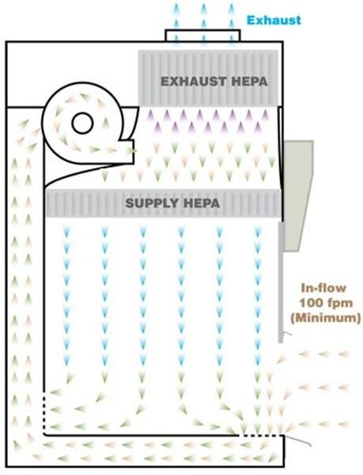
A major task of the cell biologist is to perform cell culture, a process of growing cells under controlled conditions. Several pieces of equipment are used in cell culture: a ‘hood’, a CO₂ incubator, a bucket centrifuge and an inverted microscope.

A ‘hood’ allows a cell biologist to keep a ‘pure’ culture of cells (not contaminated by other cell types). The ‘hood’ used for cell culture is a Biological Safety Cabinet – Class II. It is a laminar flow hood that intakes air from the room through a front grating system. This air runs behind the unit into a high-efficiency particulate absorption (HEPA) air filter that filters out any particulate bigger than 200 nm. The air from this supply HEPA is now allowed to flow toward the work space where the product (e.g. cell line) is being manipulated. The air then flows from the work space through a rear grating system into the back of the unit (away from the workspace). This air run through an exhaust HEPA and allowed to exit back into the room. Therefore, the BSC-Class II protects the environment, person and product. It can be identified from other hoods in the laboratory by a label.

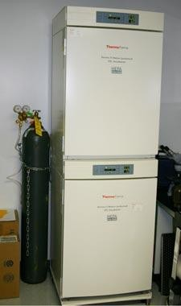
A CO₂ incubator provides the environment where the cells grow and are maintained. To keep cells alive, we must mimic their original environment.
For example, if we are growing eukaryotic mammalian cells, they will need a temperature that mimics body temperature (37˚C (~98˚F)), 95% humidity (water source) and a system to control pH at neutrality such as 5% CO₂ in combination with bicarbonate.
A CO₂ incubator can be identified by the tube that leads from the incubator to a nearby CO₂ gas tank. It is usually set to 37˚C and 5% CO₂. We should be able to hear the clicking sound associated with the CO₂ being pumped into the incubator.

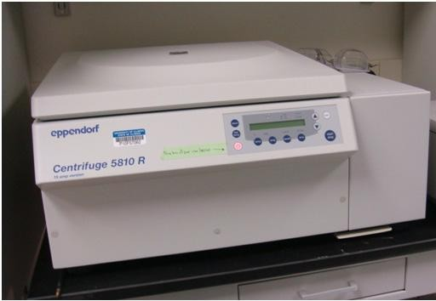
To move cells from place to place and/or change their concentration, we will have to pellet the cells away from the liquid in which they are living (media). To accomplish this goal, we will get the cells into suspension (different methods will be present during splitting cells lab) and transfer them into a tube (example, 15 mL tube – see supplies inventory). We will use a bucket centrifuge that will use centrifugal force (1000-1200 rpm, 5 minutes) to move the cells into a pellet. Now we can remove the supernatant and are left with a pellet of concentrated cells. The rotor in a bucket centrifuge swings, unlike a fixed rotor centrifuge.
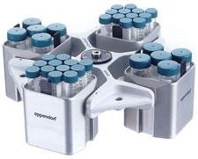

In cell culture, we usually use a dish or flask for growing cells. These vials do not fit in the working distance of an upright microscope. Most cell biologists have inverted microscopes where the objectives have been moved to below rather than above the stage. An inverted microscope is similar to an upright microscope having oculars, course focus knob, different magnifying objective, a stage and an iris diaphragm to adjust the light.
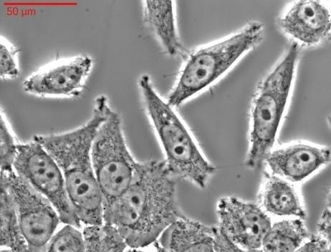
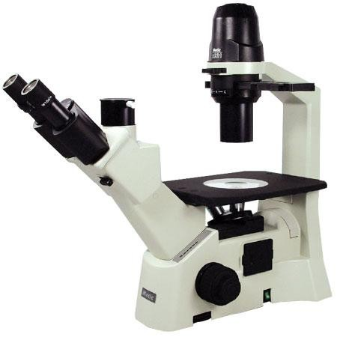
In addition, an inverted microscope usually has a phase contrast filter to convert phases of light that pass through a transparent object into difference in object brightness. Phase contrast allows a cell biologist to easily distinguish the different parts of a cell without the need for staining like methylene blue.

SUPPLIES

Certain supplies are common to all labs. Laboratory supplies are classified as nonconsumable (used over and over) or consumable (used up, a cell biologists is responsible for the inventory of these supplies and replenishing supplies when low).

Consumable supplies need replacing because they are used once and then thrown away. In a cell biology lab, most of the consumable supplies are sterile (all living organisms have been removed). Sterile supplies are labeled in various ways, such as with autoclave tape or being individually wrapped. They are no longer sterile once opened or used.

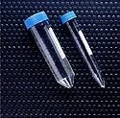
Consumable supplies needed for cell biology laboratories include serological pipettes, pipetman tips, conical tubes, cell culture T25 flasks and C60 dishes. Several sizes of each of these are needed.
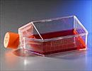
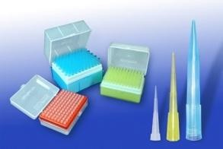

Nonconsumable supplies needed for a cell biology laboratory include a plastic beaker (for disposing of liquid), tube racks to hold tubes, markers and a spray bottle. Several nonconsumable supplies do not need to be ordered more than once and are usually found in the lab, such as scissors, transfer pipets, lens paper, paper towels, parafilm, biohazard bins.

TASK 1.2
- Watch the 6:04 minute video entitled “cell culture laboratory and equipment” for a tour of common cell biology equipment.
https://youtu.be/CA5fVLK5zAE
- Using the introductions and team work discussion forum posted in Blackboard to create a team of no more than 3 people from the class. You can contact possible team mates through the discussion forum or by Email.

- Exchange contact information and agree upon a group name (shorter name, less labeling).

- Each group can work together on completing tasks. Although, you can work on tasks together, each student is responsible for on-time completion of their own assignments.

- Use fishersci.com to search for two of the catalog numbers seen in the pictures below. Find the name, unit and price of two consumable supplies; one of the serological pipets (top picture) and one of the tubes (bottom pictures). This information is needed to answer a worksheet question posted to Bb.

Note: Naming common consumable supplies is a learning objective for the lab.

\
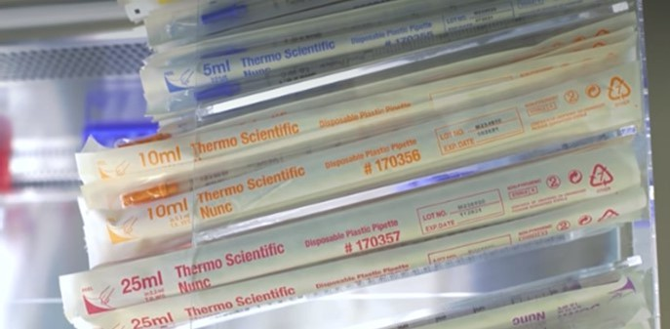

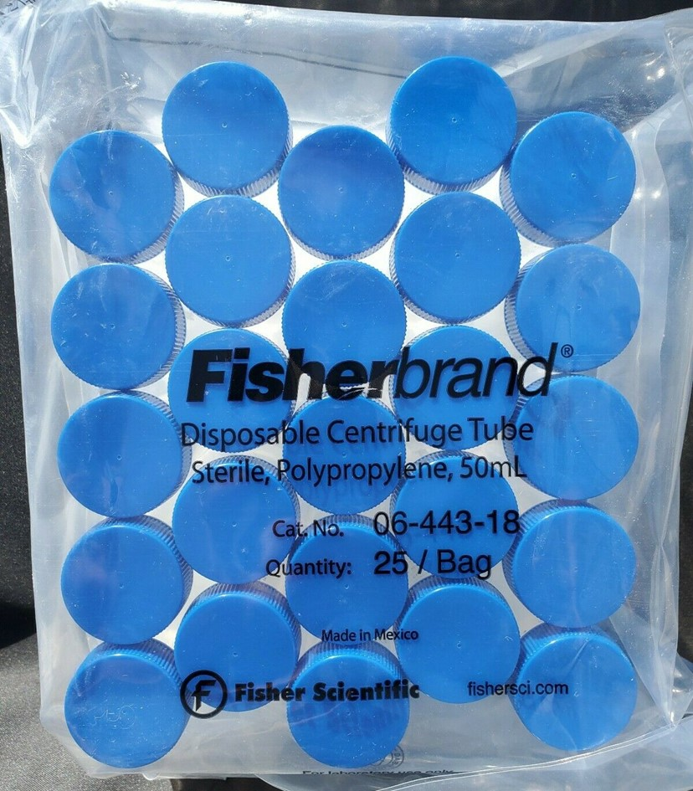
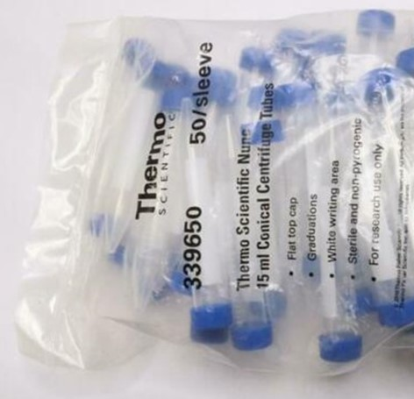

- Get acquainted with the equipment and supplies. Review the inventory below and based on the information given in the background differentiate between nonconsumable and consumable supplies. These supplies are common to a cell biology laboratory. Pictures above are of serological pipettes and conical tubes. The catalog number of each is displayed in the picture. Are these nonconsumable or consumable?

INVENTORY
Supplies that are housed in the lab room
- Bottles of liquid disinfecting solution (example, Lysol)
- Pipet Aids
- Pipetmen
- Carboy of distilled water
- Minicentrifuge and Minivortex

List of supplies

Nonconsumables

- Plastic beaker (>500mL) for Lysol
- Empty Styrofoam 50mL tube rack
- Empty Styrofoam 15mL tube rack
- 1.5mL tube rack
- Sharpie – fine/thick tip
- Spray bottle
- Roll Lab Tape (any color)

Consumables

- C60, or 60 mm tissue culture treated dishes (one bag)
- T25 tissue culture treated flasks ( bag)
- Serological pipettes , 5 mL (two sleeves)
- Serological pipettes, 10 mL (one sleeve)
- Serological pipettes, 25mL (one sleeve)
- 15mL tubes (one bag)
- 50mL tubes (one bag)
- Container with sterile 1.5 mL tubes
- sterile yellow tips (one box)
- sterile blue tips (one box)

Microscopy
Purpose
The main purpose of this laboratory is to identify the parts of and understand how to use an inverted microscope to view cells grown in cell culture.
Background
Conventionally, cells grown in cell culture are in suspension or adherent to flat, plastic vessels. If the cells are adherent, the plastic is treated to enhance cell attachment. For example, the vessel can be coated with gelatin, a protein obtained from skin that contains positively charged amino acids, such as arginine and lysine. The cells are more likely to stick to cell culture treated plastic than regular plastic. As such, these special vessels are marked to indicate that they are treated for cell culture, such as “C” for culture-treated or “T” for tissue-culture treated.

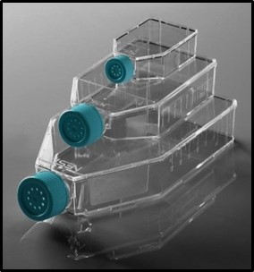
Additionally, cell culture vessels are defined by their approximate dimensions or format. For example, a C60 dish is a culture treated dish with approximately a 60 mm diameter and a T25 flask is a culture treated flask with 2500 mm² of surface area. We are going to use either a 60 mm dish (C60) or a vented T25 flask to grow our HeLa cells.

To view cells in culture with an upright microscope, we could float a coverslip in the vessel and then transfer it to a microscope slide, buy expensive vessels with removable sides or even saw off the sides of the vessels. Or, we could use an inverted microscope, which was invented by Dr. J. Lawrence Smith in 1850.

An inverted microscope has its objective underneath the stage. These are pointing upward to the bottom of the sample. The light is directed to the sample from a condenser lens above the sample. Cells in culture are colorless, transparent and difficult to distinguish from their surroundings by conventional bright field microscopy. So we are going to use phase contrast microscopy, developed by Dr. Frits Zernike in the 1930s, which applies rings to the condenser and objective to create interference light patterns in the sample. Phase contrast results in a phase shift in the wavelength of light reaching the eye and enhances our ability to distinguish differences in object brightness or give the cells more contrast.

Inverted microscopes are expensive (example, an AccuScope EXI-300 inverted microscope costs ~$4,000), so they should be handled with great care. A lot of lab work in a cell biology laboratory is done using an inverted microscope, such as the Olympus CKX41.

Today, we are going to become familiar with using an inverted microscope and identifying its parts, including the phase contrast filter.

TASK 1.3
- Read the background for microscopy, particularly the description of phase contrast.

- Use the picture of an inverted microscope below to help label the parts in the WS.

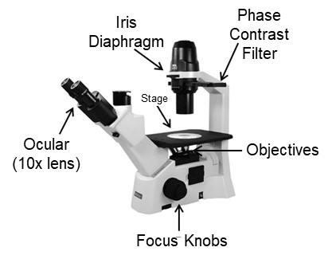

- Watch the 1:34 minute video entitled “Nikon Eclipse TS 100 Inverted Microscope” to see a close up view of all the parts of an inverted microscope. Use the close up view of the objectives at the end of the video to answer the objective question in the WS.
https://youtu.be/aqa2oeygKSU
- Watch 3:52 minute video entitled “Inverted Microscope Explanation” to see how to use an inverted microscope. Steps for use listed at end. Use information in the background to review the general parts of a microscope and their function.
https://youtu.be/b_HO447d9hg
- The size of cells viewed under the microscope is an integral part of studying cell biology. Read through the following concepts to determine how many cells could fit in the FOV* when the microscope is on a particular objective. Using cell size and the size of a FOV*, we are able to approximate how many cells we should see at each magnification+. Practice below and then work on problem in WS.

*Field of View (FOV) is the circular field we see when looking through the ocular lens. Knowing the diameter of the FOV helps us get a general sense of the cell size.

+Total magnification is the objective lens’ magnification multiplied by 10 (magnification provided by ocular). By indicating the total magnification used to view the cell, we have a sense of the size of the field of view, which give us a general sense of the size of the cells being viewed.

Practice: 10x objectives show a field of view (FOV) of ~2000 microns [2mm]. The average red blood cell has a diameter of ~8 microns. So a 10x FOV could fit ____ cells.

The following is a set of instructions for using an inverted microscope.

Set up and place dish/flask for viewing
- Use both hands to set microscope on counter. Remove and store cover
- Unwind cord and plug into socket, making sure cord does not dangle off the bench
- Turn on microscope with toggle switch. Adjust light with rotating dial on side
- Use nosepiece at base of microscope to rotate objectives to lowest objective
- Use course focus knob to move nosepiece up to stage
Observation of a specimen
- Make sure to slide phase slider to middle position (the phase contrast filter)
If microscope has a “PH0” knob on side of arm, turn to activate phase contrast.
- Starting with lowest objective, use coarse adjustment to focus. Hint: look through the eyepiece and move the sample. If you are actually focused on the sample than it should be moving. Fine tune focus with fine adjustment knob (smaller knob).
- Place sample on stage. Move sample with hand until centered over light.
- Microscope is parfocal, so the objectives can be changed with minimal focusing needed between them; Switch to higher objective. Use fine focus knob to focus.
- As increase magnification, adjust the light by adjusting the dial on the side
Clean up and put away
- Go back to lowest objective.
- Clean the stage and lenses with lens paper.
- Switch light off, coil cable, and cover microscope before putting away.

Liquid Transfer
Purpose
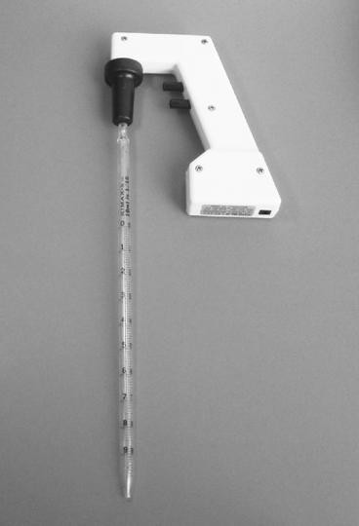
The main purpose of this laboratory is to learn how to transfer liquid from one vessel to another. In cell biology, we maintain cells at a particular concentration by moving them from their current flask/dish into another flask/dish using liquid transfer techniques.

Background
In order to transfer liquid in the lab, use two different tools: a pipet-aid (also called a pipet filler) and a pipetman (example Finnpipette®).

A pipet-aid is used to draw up greater than 1 mL of liquid and transfer it to another location. It fits different volume serological pipettes (have 5 mL, 10 mL and 25 mL). The serological pipettes have a cotton plug to catch liquid that goes beyond the volume of the pipette. However, any additional liquid will enter the mechanical part of the pipet-aid and hamper its function. Usage of the appropriate serological pipet for the volume needed is essential.
The pipet-aid has two buttons on its stem. The top button is for sucking up liquid into the serological pipet once the tip of the serological pipet is in the liquid of choice. The bottom button is for releasing the liquid once the tip of the serological pipet has been moved to the appropriate tube. Sometimes these buttons have speed (slow, medium fast), slow speed (S) is recommended. To work the pipet-aid you will gently push serological pipet into the stem, put the serological pipet tip into the liquid, gently press top button until reach volume desired, release top button, move tip to other vial and gently press bottom button to release liquid. Remove serological pipet once done. Note: number marking are sometimes backwards where 1 mL is marked on the top of the pipet.

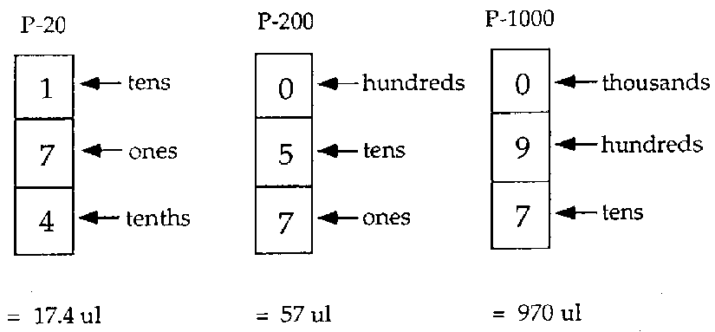
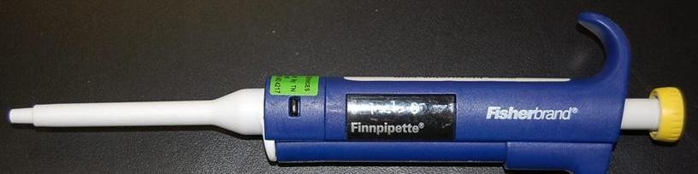
A pipetman is used to draw up less than 1 mL of liquid and transfer it to another location. There are several different types of pipetman in this lab and each pipetman has its own way of working, usually the volume is changed by turning the knob, but sometimes knob needs unlocking.

Each pipetman has its own way of displaying volumes. P-20 pipetman range in volumes up to 20 µL. They give the ability to pipet a tenth of a µL (example, 17.4 µL). P-200 pipetman range in volumes upto 200 µL. P-1000 pipetman range in volumes upto 1000 µL (note: 1000 µL is equal to 1 mL). Each pipetman has its range of volumes printed on the side. Check this before using it. If use a volume beyond the capacity of the pipetman, it breaks. Become familiar with each type and ‘range of volume’ pipetman.
Each pipetman fits a different tip type. In most cases, a pipetman that can pipet a volume of 1000 µL fits a blue tip. All other pipetman volumes usually fit a yellow tip. The blue/yellow tips in the boxes have been autoclaved for sterility. Open them for minimal amounts of time.

To work the pipetman, gently put the pipetman over a tip and push down to engage the tip onto the pipetman [do not use hands as the tips are sterile], gently press the top button down until reach the first stop, keep the button depressed, put the pipet tip well into the liquid, slowly release the top button, move tip to other vial and gently press top button to second stop to release liquid. The second stop is also used for repeat pipetting and gives extra working volume beyond the value set on the pipetman. Remove tip once done.

There are a variety of different tubes that hold a variety of different volumes; 50 mL tube, 15 mL tubes and 1.5 mL tubes. Although these tubes are packaged in bulk, they are sterile on the inside.

TASK 1.4
- Watch the 4:44 minute video entitled “Using serological pipets” for a demo on how to accurately liquid transfer using a pipet-aid and serological pipette. I use his technique mostly when the procedure calls for liquid transfer volumes of ~0.5 mL to 35 ml, depending on the size of serological pipets that I have available.
https://youtu.be/4VTTE_oWs58
- Watch the 1:11 minute video entitled “Serological Pipette” to see how to measure the volume of liquid in a serological pipet.
https://youtu.be/aei-tU1ZIkE
- Watch the 1:51 minute video entitled “How to use a Micropipette” for a demo on how to accurately liquid transfer using a pipetman and tip. I use his technique mostly when the procedure calls for liquid transfer volumes of 1 mL (1000 µL) or less, depending on if it works with my sterile technique.
https://youtu.be/352RiEMekJU

- Watch the 3:41 minute video entitled “How to use a Micropipette”, particularly watch the end of the video to get information needed to answer a worksheet question.
https://youtu.be/TFXX8yCWjMo

A cell biologist needs to be adept at choosing the appropriate pipet/tip (5 mL, 10 mL, 25 mL serological pipet OR blue/yellow tip) and tube (1.5 mL, 15 mL or 50 mL).

COMPLETE WORKSHEET……

